🚀 **Best Cars Dealership Portal – Capstone Project Submission**

**📘 1. Project Repository**

GitHub Repository URL:

<https://github.com/edukojumanikumar/best-cars-dealership-portal.git>

**🌐 2. Application Deployments**

Django Application Deployment URL: <https://manikumaredu-3030.theiadockernext-1-labs-prod-theiak8s-4-tor01.proxy.cognitiveclass.ai>

Sentiment Analyzer Deployment URL:

<https://sentianalyzer.1xaue8mwgtmf.us-south.codeengine.appdomain.cloud/>

**🧩 3. Screenshots**

Below are the screenshots for each required task:

✅ Task 2: Django server running

Screenshot:

**

**✅ Task 4: Contact Us page**

**✅ Task 5: Login page**

✅ **Task 6: Logout alert**

**✅ Task 7: Sign-Up page**

**✅ Task 8: Dealer reviews (Express/Mongo)**

**✅ Task 9: All dealers (Express/Mongo)**

**✅ Task 10: Dealer details (Express/Mongo)**

**✅ Task 11: Dealers filtered by state (Express/Mongo)**

**✅ Task 12: Admin login (root user)**

**✅ Task 13: Admin logout screen**

**✅ Task 14: Car Makes in admin panel**

**✅ Task 15: Car Models in admin panel**

✅ **Task 16: Sentiment analyzer working**

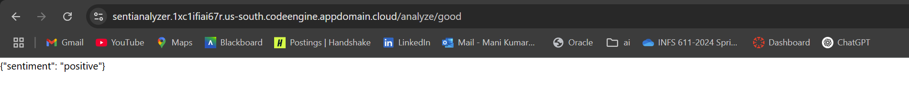

**✅ Task 17: Home page before login**

**✅ Task 18: Home page after login**

**✅ Task 19: Dealers filtered by state on homepage**

**✅ Task 20: Dealer details with reviews**

**✅ Task 21: Add Review page (before submission)**

**✅ Task 22: Added Review confirmation**

**✅ Task 23: CI/CD workflow success**

**✅ Task 24: Django deployment URL**

URL: <https://manikumaredu-8000.theiadockernext-1-labs-prod-theiak8s-4-tor01.proxy.cognitiveclass.ai/>

**✅ Task 25: Deployed app landing page**

**✅ Task 26: Deployed app logged-in page**

**✅ Task 27: Deployed dealer details page**

**✅ Task 28: Review added through deployment**

